**Steps For Deploying Spring Boot App With Angular On AWS EC-2 Instance And RDS**

Steps To Create Jar File Of Spring Boot App

1.Navigate To your project right click and Do Maven Build with command “install” and by skiping test ,Do Apply and run.

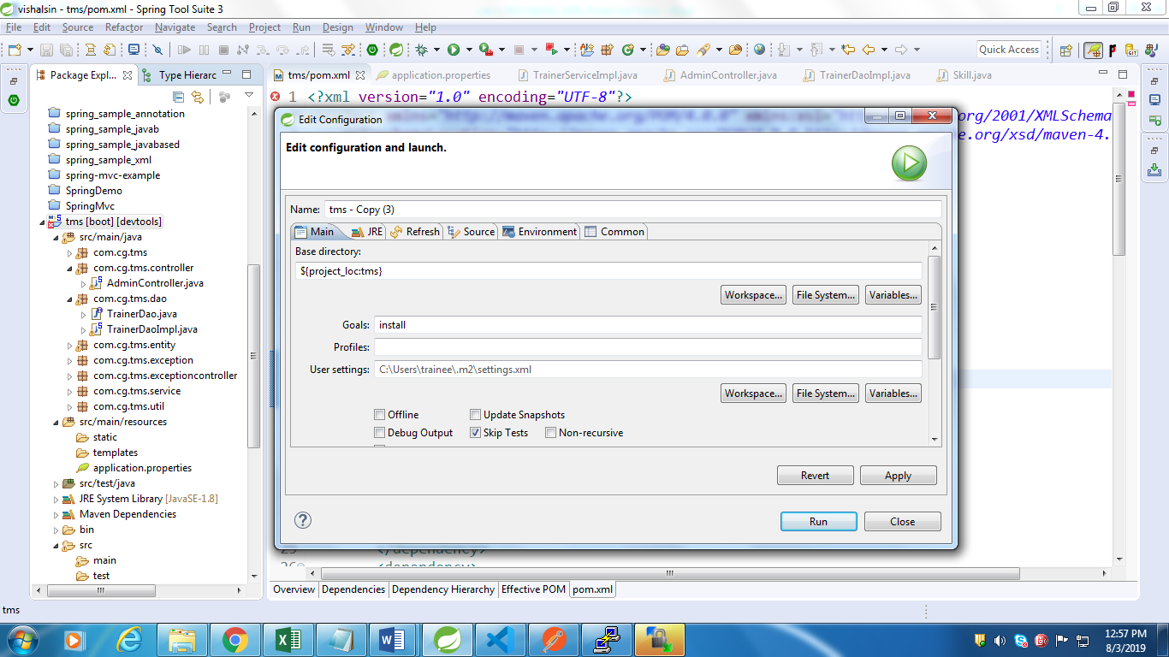

2.Now Check the jar file build after doing above operation and find it in target folder under your application

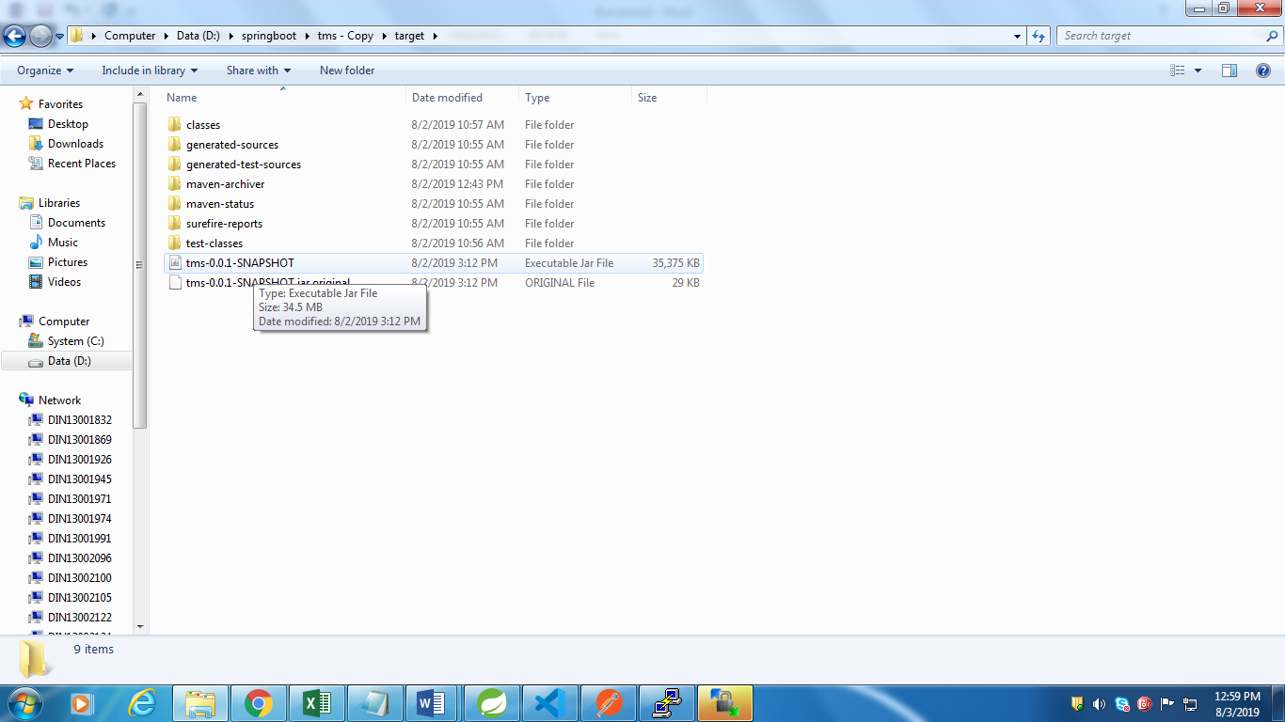

3.Now transfer the jar file to S3 aws bucket…So that it can be share to anyone

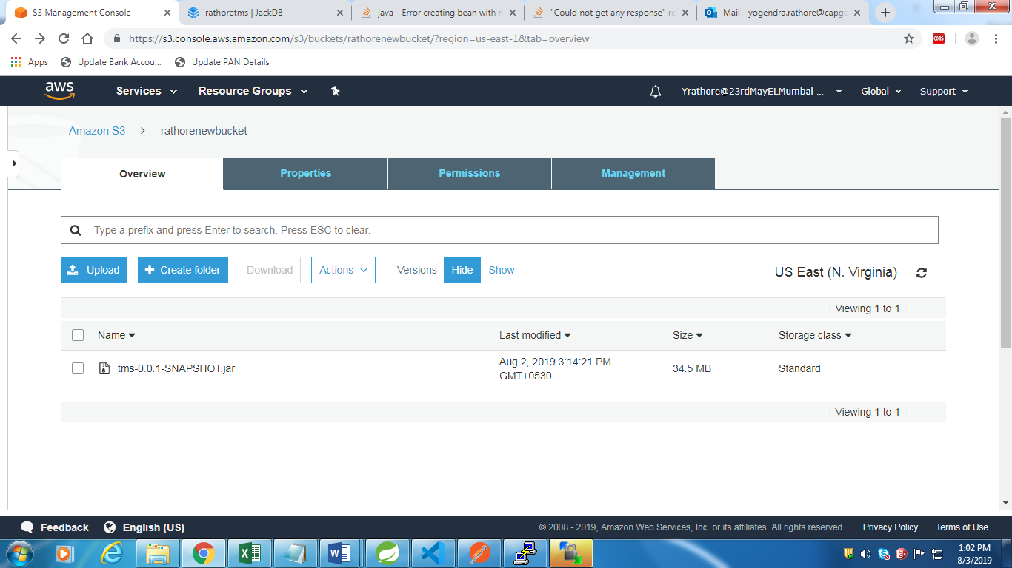

4.Make this public and copy the link of that object of your newly created bucket

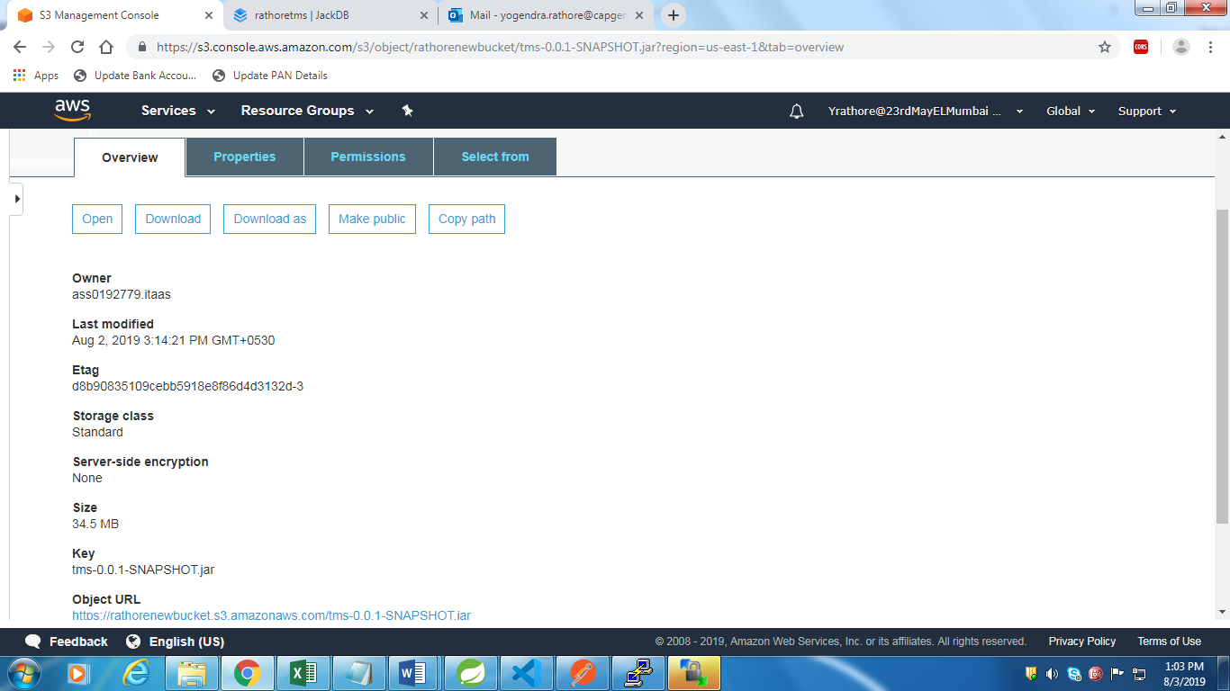

5.Now get your ec2 instance console using putty and puttygen…

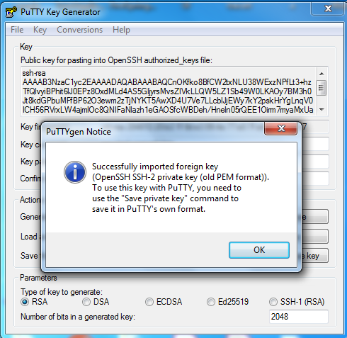

6.Open putty and add ppk key to get ec2 console

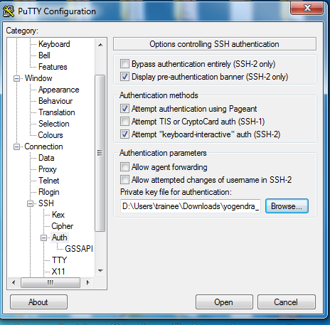

7.Now click Open and type ec2-user and get console….

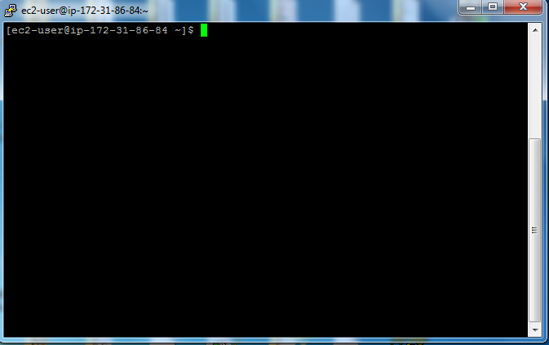

8.Now run wget command to get jar file from S3 bucket and do ls command to check that jar file is there or not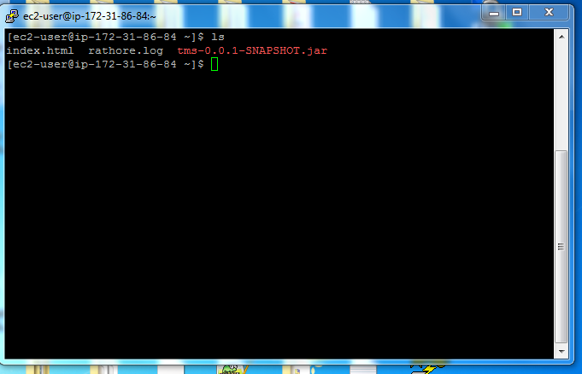

9.Now Run your RDS instance on AWS..

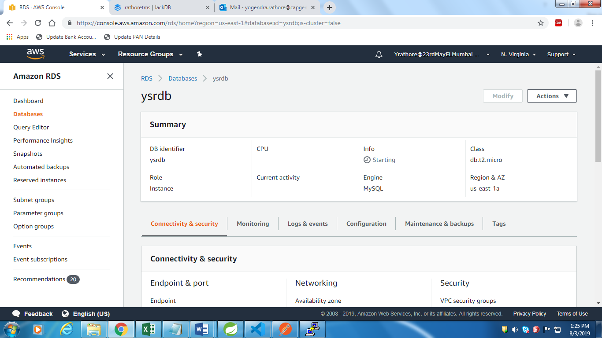

10.Now Open visual code editor and do “ng build command” on your angular project…..

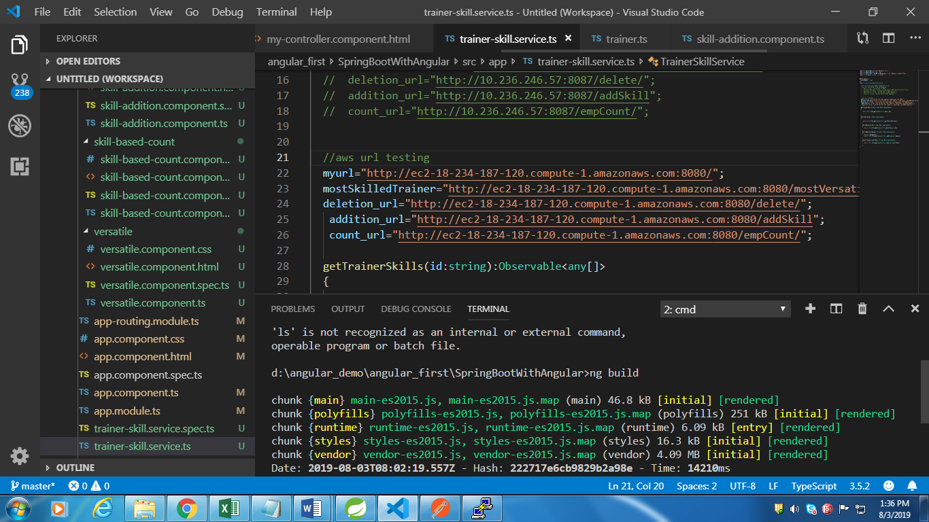

…

11. Now go to your angular project location and find out the dist folder…

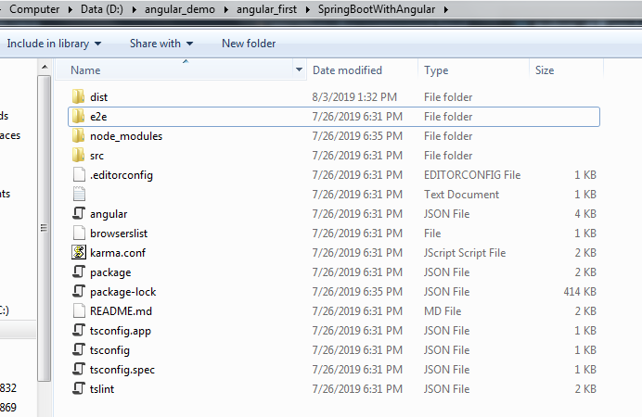

12.Now transfer this dist folder to your running ec2 instance using WINSCP

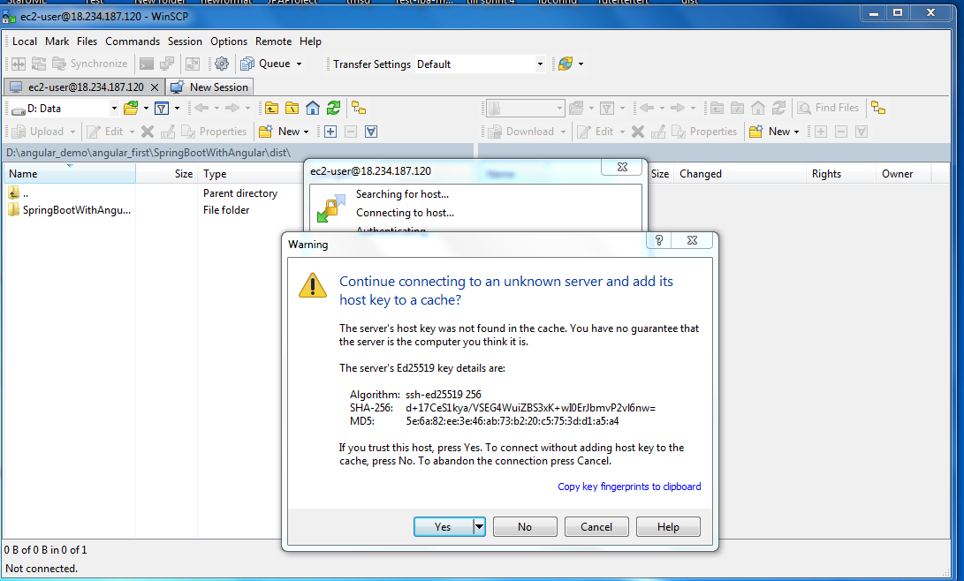

13.Go to dist folder and copy that to your ec2 instance using drag and drop operation..

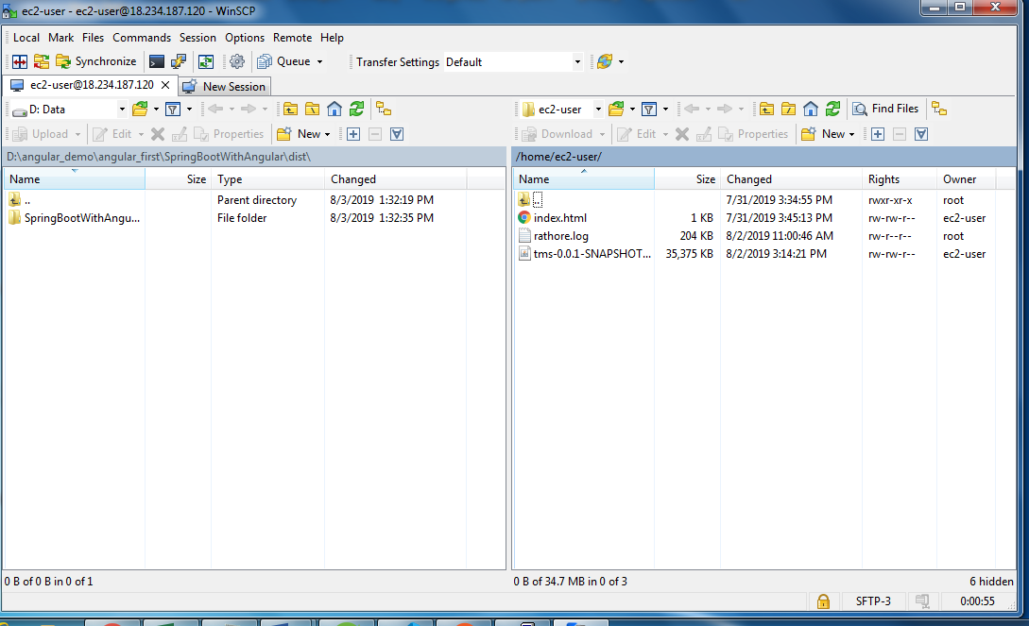

Drag and drop to copy

14.Now copy all dist folder files from home directory to /var/www/html/ directory

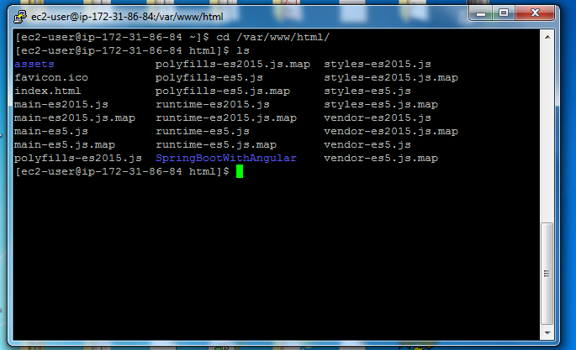

15.Now run command “sudo service httpd restart”

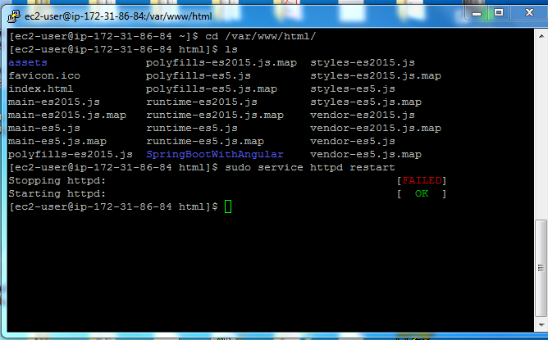

16.Now go to your directory where your Spring boot jar file is there

i.e “cd ~” and do ls

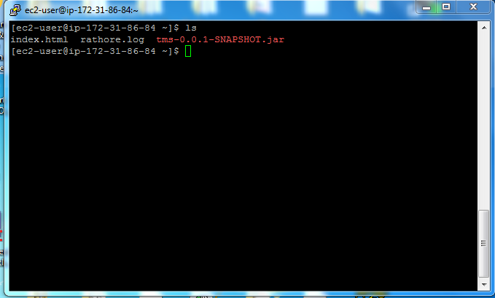

17.Now run command “java –jar jarfile name”

And Now your spring boot app with angular is started

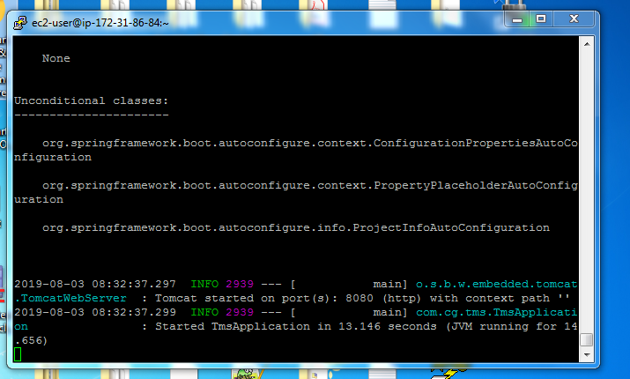

18.Now copy your ec2-instance public DNS and paste it in your browser

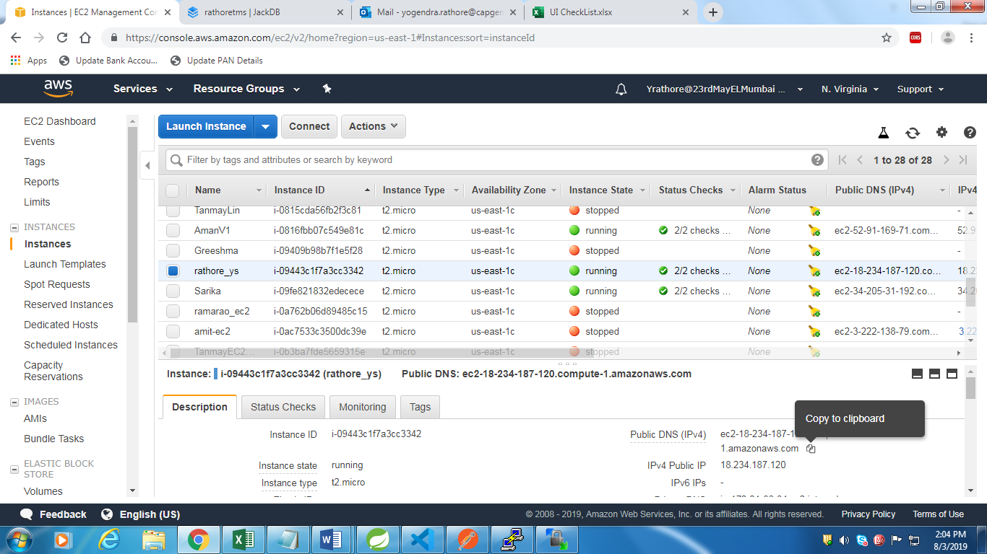

19.Open it in your browser

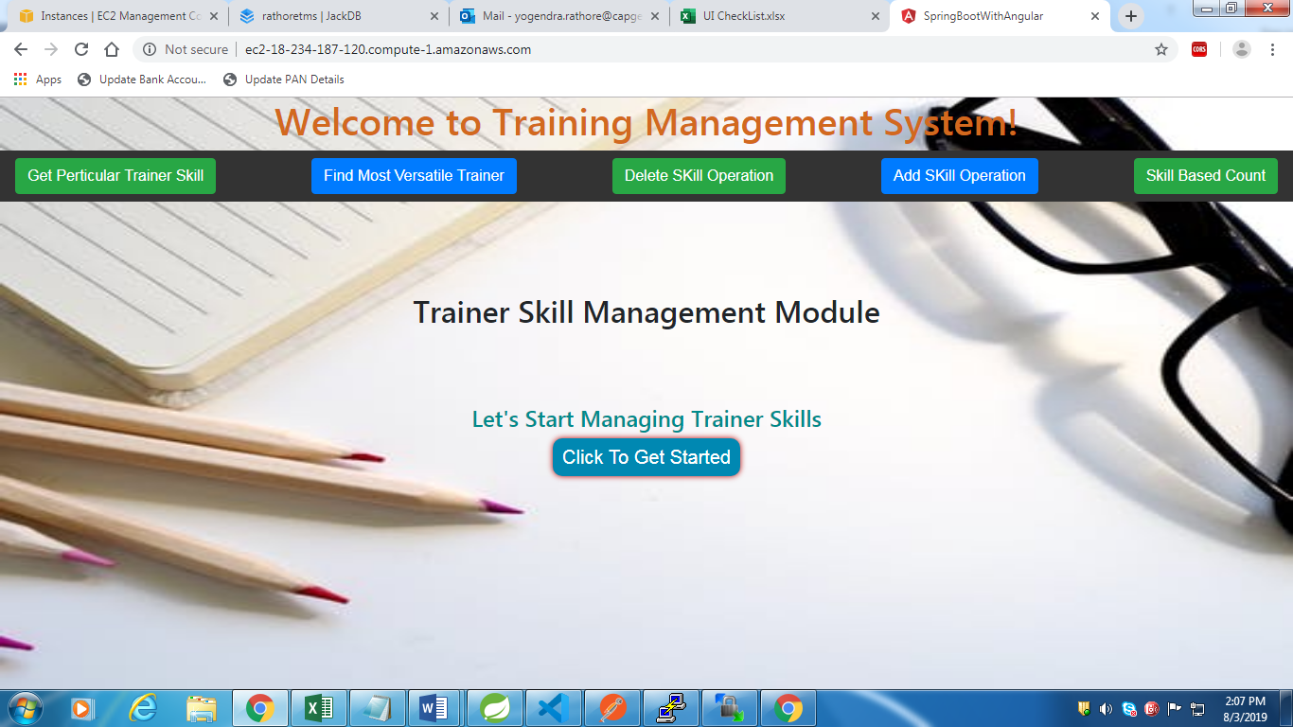

Now your website on cloud…